NOTICE TO VACATE

The Minnesota Department of Transportation, City of Saint Paul and Ramsey County Public Health request your assistance to protect your health and safety.

This site will be permanently cleared at 10AM on Thursday, November 15th.

You are required to vacate the site and not return. Please remove all of your personal belongings, including any tents or similar structures, clothing, bedding and household items before 10AM on Thursday, November 15th.

Work crews will then remove any remaining items and debris and clean the site. All items remaining on the site after 10AM will be considered abandoned and will be disposed of.

The Saint Paul Police Department will be available to provide transport to shelters located within the City of Saint Paul.

Outreach workers from Outside In, People Inc., and RADIAS Health are visiting this site regularly. We strongly encourage you to connect with those resources to help find housing.

In addition, you can access these resources by contacting providers below directly.

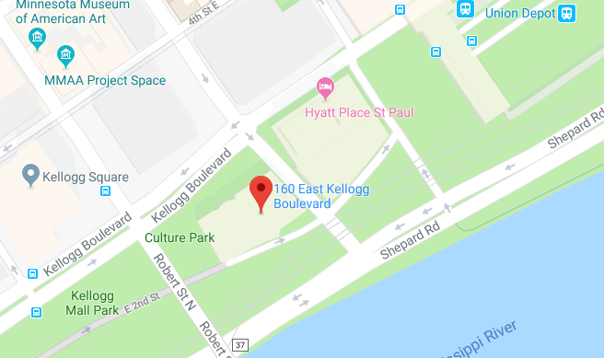
WINTER SAFE SPACE-OPENED NOVEMBER 1ST
Temporary Overnight Shelter
160 E Kellogg Blvd (Former Ramsey
County Detoxification Center)
Hours: 10pm-9am, 7 days a week
Occupants need a referral from the
Saint Paul Police Department, Metro
Transit, local outreach organization
(see below)

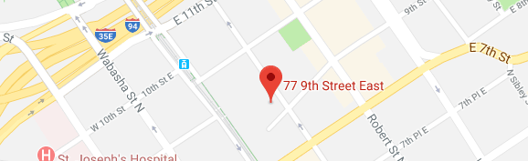
UNION GOSPEL MISSION
77 East 9th Street
Saint Paul, MN 55101
651-228-1800

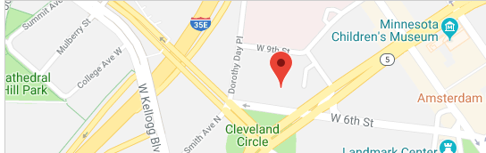
CATHOLIC CHARITIES-HIGHER GROUND
435 Dorothy Day Place
Saint Paul, MN 55102
651-647-2330

Ramsey County Housing Assistance
Housing assistance varies depending upon your situation:
- Families with children-call 2-1-1 (or 651-291-0211)
- Adults (age 25 and older) -- call Catholic Charities at 651-647-2350
- Youth (24 years and younger, not with your family) – call the
SafeZone at 651-224-9644
- Veterans -- Call Ramsey County Veterans Services at 651-266-2545

Outside-In
Provides assistance to unsheltered individuals in and around downtown St. Paul to access housing, benefits, identification and other services.
Drop-In Times
  - George Latimer Central Library (90 West 4th Street)
    - Tuesdays and Thursdays: 9AM-10AM
    - Wednesdays: 1:30PM-3PM
Outside-In@PeopleIncorporated.org
651.228.3912

